**EHS PTSA General Membership Meeting MINUTES**

**Jan 22, 2025**

**6:30pm-8pm, Zoom**

**Pending – Not Yet Approved**

***Call to order:*** *6:30pm*

**Present & Absent:** See Appendix A

**Call to Order/Intros-Julie & Candice**

* Welcome!

**Attendance and Correspondence – Nicole**

* Minutes from Oct 2024 have been moved into record

**Financial Report\Mid-Year Financial Review– Heather**

* Oct
  + Starting Balance: $88,583,15
  + Ending Balance: $96,372.16
* Nov
  + Starting Balance: $96,372.16
  + Ending Balance: $94,509.00
* Dec
  + Starting Balance: $94,509.00
  + Ending Balance: $93,533.93
* Mid-year financial review was done today by Cathy Godfrey, Alexandria Reyes and Leta Hamilton. There were no areas of concern. There were some minor notes passed onto Heather. Deposits didn’t match for 2 months; they were off because something looked like a deposit and was put into Senior appeals for Angels. There were a couple of missing signatures on forms missing. A document was missing in a binder. Very detailed review.

**Grants Report – Kerri Miller**

* Grants Report Slide in Appendix B

**Approvals -**

* Budget Reallocations - Heather Champman
  + Budget Revisions Slide in Appendix C
  + **Motion:** To Approve Budget Proposal 1 made by Brett Waldbaum, 2nd Heather Chapman. **Passes with 1 Abstain.**
  + **Motion:** To Approve Budget Proposal 2 made by Jen Fowler, 2nd Suzy Khendry. **Passes.**
  + **Motion:** To Approve Budget Proposal 3 made by Jeannette Illsley, 2nd Shirley Brill. **Passes.**
* Nomination Committee – Candice Wheeler
  + Anu Chinta
  + Heather Chapman
  + Cathy Godrey
  + **Motion:** Approve the Nominating Committee as listed above made by Christine Cherkis, 2nd Jennifer O'Donnell. **Passes.**

**Holiday Bazaar Recap – Holiday Bazaar Committee**

* 31st Holiday Bazaar 140 vendors and still had to turn vendors away.
* Netted over 17k for the PTSA.
* Lots of positive feedback for the student volunteers from vendors.
* Save The Date for next year's Holiday Bazaar: Saturday Nov 8, 2025

**Senior Activities Update – Kimbra Ong & Christine Cherkis**

* Gave update on Pre-Commencement Celebration, Grad Night, Grad Walks, Grad Signs, Fund Senior Breakfast, Fundraisers
* Selling Grad Night tickets now, we have sold double than we did the same time last year. The locations of Grad Night are kept secret for safety (and fun). Grad Night is on June 17 right after graduation and returns the morning of June 18.

**Upcoming Volunteer Opportunities– Candice Wheeler/Julie Kotler**

* Judges for Scholarships
* PTSA Scholarship Committee Co-Chair
* Email: [scholarships@ehsptsa.org](mailto:scholarship@ehsptsa.org)

**Principal’s Report – Todd Apple**

* Bell Schedule – coming soon. It is important for teachers to decide what to take on next year.
* Reader Board on 228th – is getting installed. PTSA paid a part of it last year through a grant. It will be installed in 2 months.
* Construction – is being delayed, doesn’t know the reason or how long it will be delayed. Hoping it is delayed until after the school year ends, so it only impacts one school year. Temporary parking permits will be valid as long as the parking lot is open; at least until spring break. The library will be in the parking lot in a portable. Leadership will be in another classroom. About 10 staff members will be moved during the construction along with the copy room, there is a plan.
* Impact on Students as we go from 7 credits to 6. It is very important for our district to provide flexibility. Some current ideas: you can take a world language competency test and receive credits. There will be some new flexibility options that will be considered for approval at the next school board meeting. Keep watching for announcements on this.
* Cell Phone Policy – it is a better environment in classrooms and hallways. Teachers are all getting a container to put their phones in. Students take a panorama survey mostly the scores don’t change much but there was one question that had a 20% increase, in student engagement. Yay!
* Incoming Freshmen Parent Night – it happened recently. We felt we missed the mark on this one, there were a lot of questions with respect to flexibility and waivers. We are considering rethinking this for next year to improve.
* Parking - there may be some more spots available, can sophomores get them? We like having some open spots as Junior and Senior get cars they can get passes. Mr. Apple will investigate if passes can be open for sophomores.
* Construction what changes? Increased capability. E Wing will get wider, 6 classrooms on each side. 2 will be science labs, 2 will be computer labs, 2 general purpose rooms. Skybridge and intersection on the 2nd floor are overcrowded, a new hallway will be built under the skybridge. This impacts the library; it will be one story and another classroom/office on top of it. Hallways will be widened. There may still be some changes to the plan.
* Will there be any locker room or weight room improvements? Athletes store stuff in cars and change clothes in cars. Some radical ideas were discussed but not adopted. We have 3 size lockers; the smaller ones are empty. Considering taking the small ones out and replacing them with ones they will use. May move the Athletic Trainers office and use that space and can access from the hallway. They will not change much but hopefully they will make them a little bit better than they are. Everything Mr. Apple is saying is a proposal, there is budget shortfall and so there will be prioritization of what goes forward and what does not.
* How do students get a locker? Kathy Kilborn in the school office coordinates wall lockers. Students should ask her. In the summer we moved a lot of lockers to add 18 inches of space in the hallway because they are not being used. Mr. Apple will follow up with Kathy about how many are left.

Meeting adjourned: 7:43pm

**Announcements**

* Join the PTSA
* Donate to Pass the Hat fundraiser at [www.ehsptsa.org](http://www.ehsptsa.org/)
* Next Membership Meeting—May 21st at 6:30 p.m. (virtual via zoom)

Appendix A – Attendance

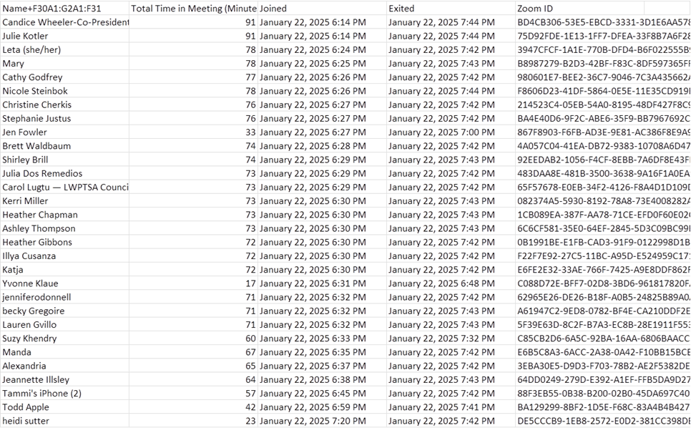

Appendix B – Grants Report

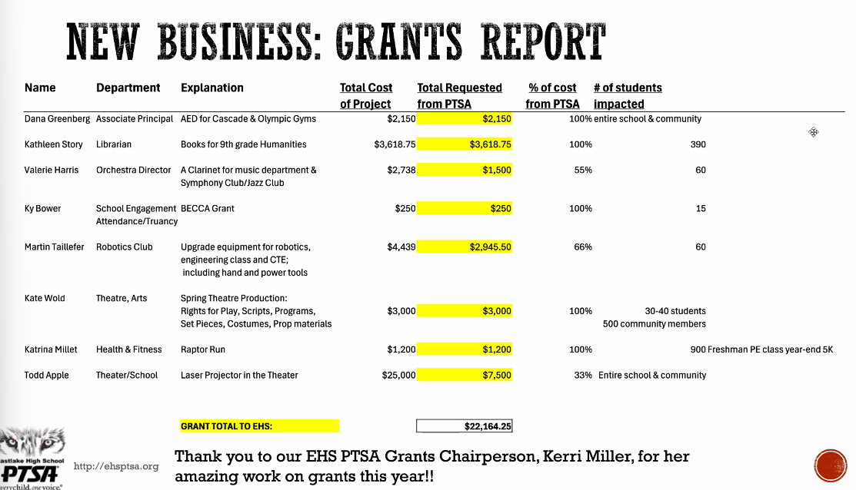

Appendix C – Budget Revisions

